Computer Fundamentals Assignment

PORTFOLIO 1

Phil ODonnell

2020-2021

# Table of Content

Table of Content 2

Introduction 3

Entity Relationship Diagram 4

Database Creation and Population 5

DROP Code 5

CREATE Code 5

Insert Values and Population 5

Queries and Results 6

Conclusion 10

Appendix A 10

SQL Code 10

# Introduction

ERD prototype for J.Neuwmann and I.Noriss (N&N) Property Viewings, to store and organise the details of viewings and to keep track of offers made by clients for properties in order to assess the effectiveness of the viewing service.

# Entity Relationship Diagram

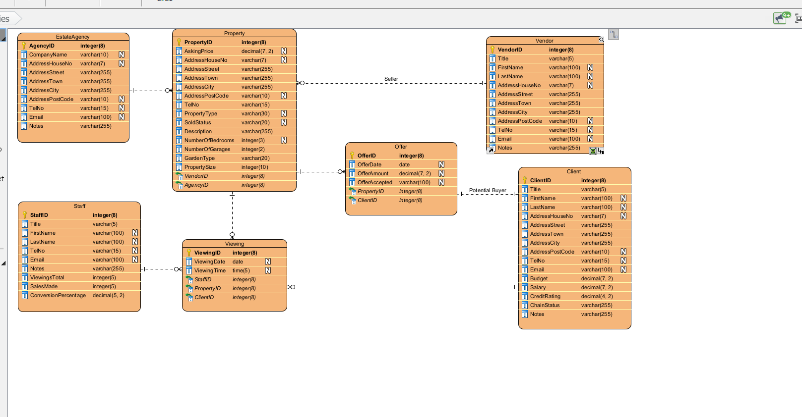

*Assumptions:*

* *Assuming that the vendor is only using one estate agency*
* *That the staff member only works for one estate agency*
* *That only one agent per estate agency is presenting the viewings*
* *That the vendor could be selling a property that is not the home in which they live.*
* *Only one vendor per property*

# Database Creation and Population

## DROP Code

*Screenshots of your SQL code for drop tables and the Output should be placed here*

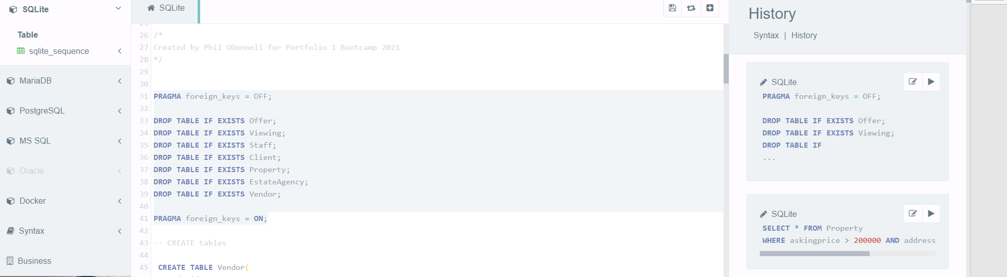

## CREATE Code

*Screenshots of your SQL code for each table and the Output should be placed here*

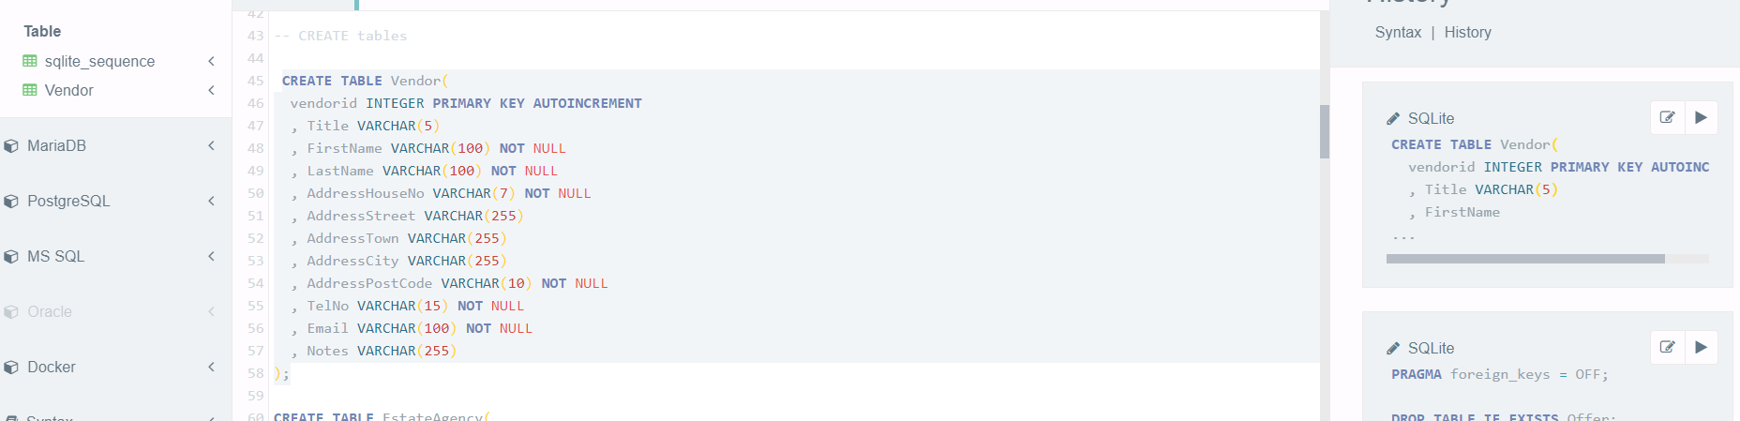

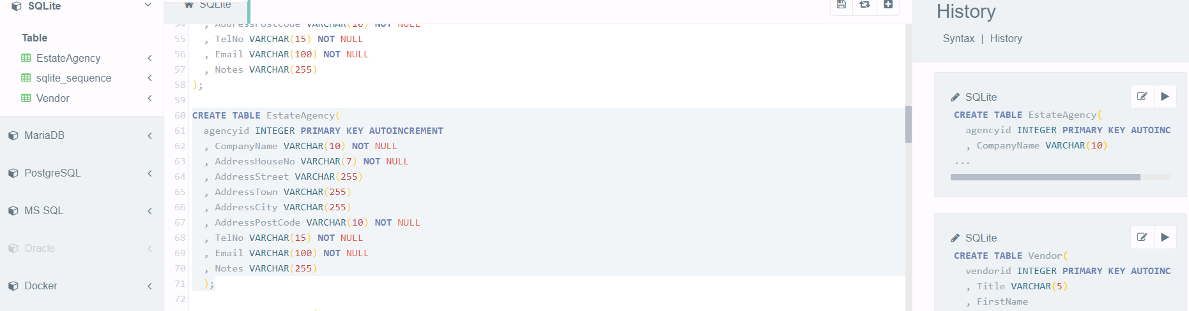

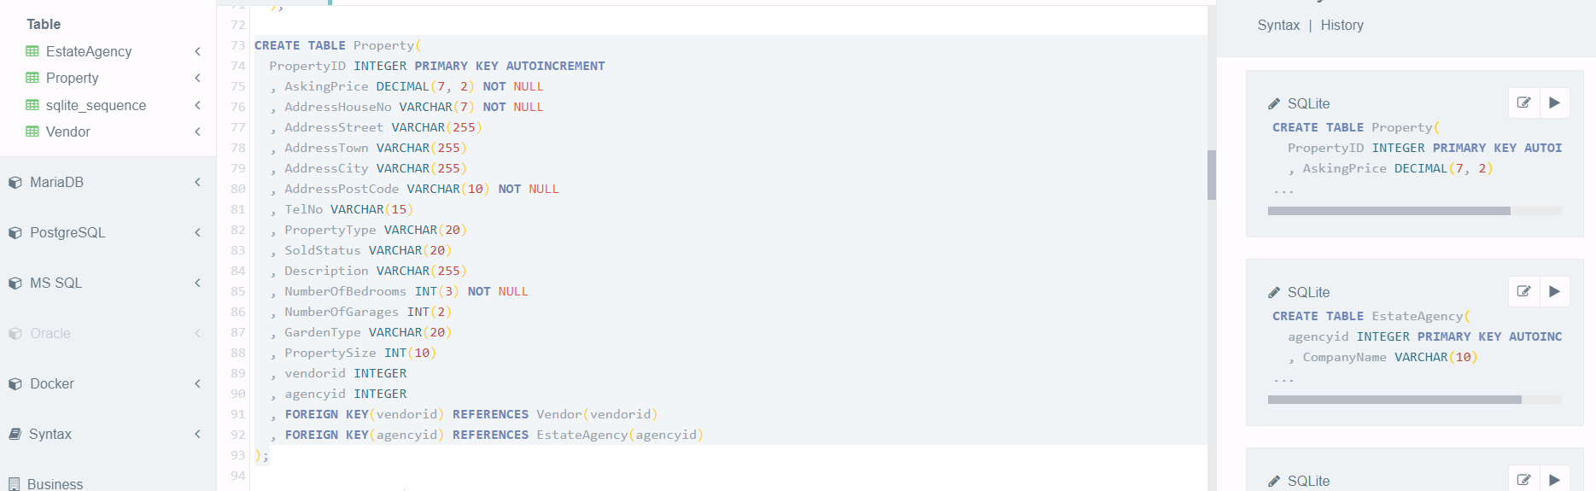

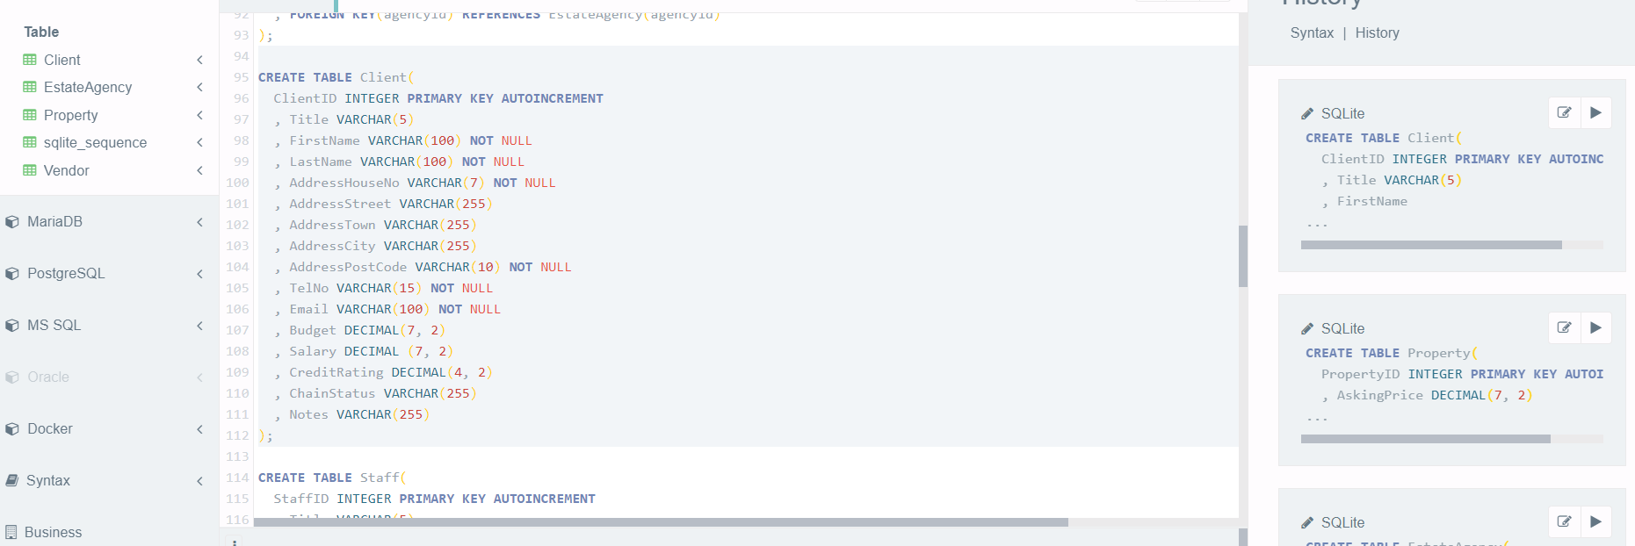

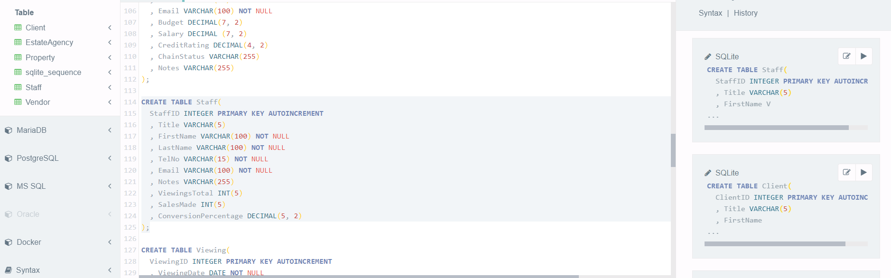

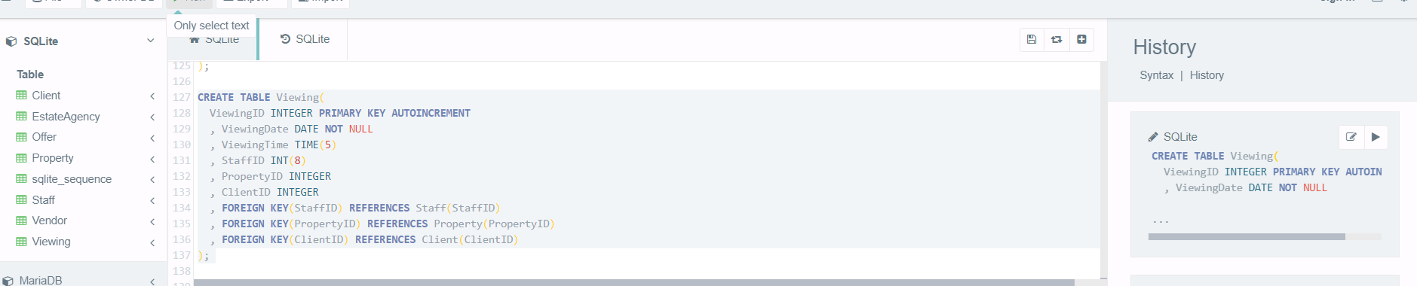

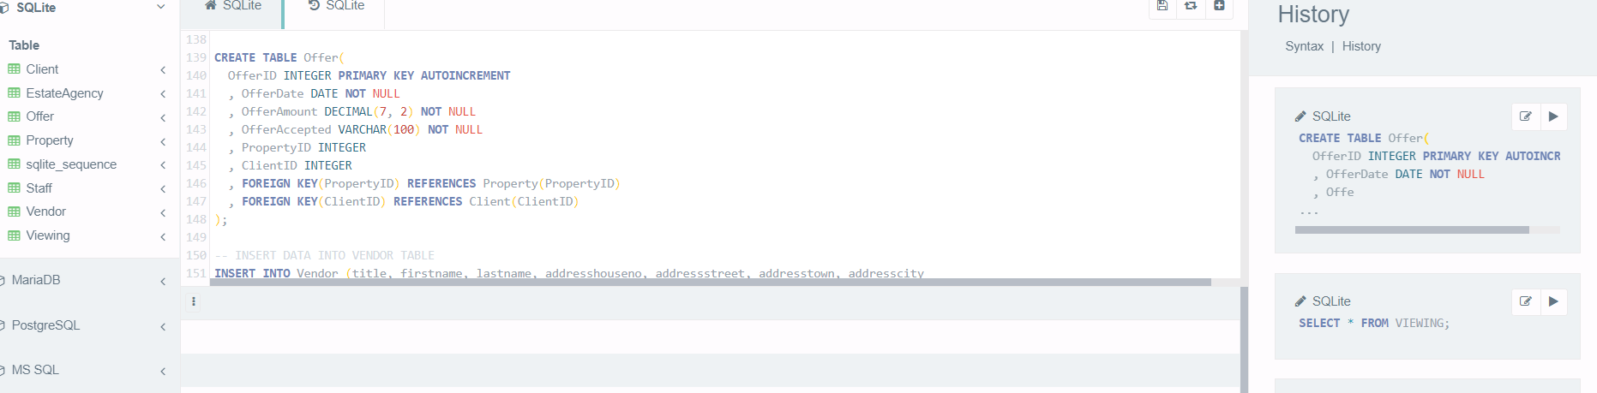

# Insert Values and Population

*Screenshots of your SQL code for each of the insert values and the Output should be placed here*

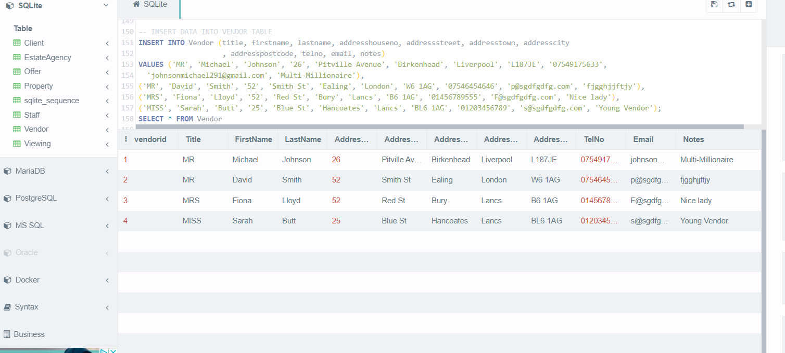

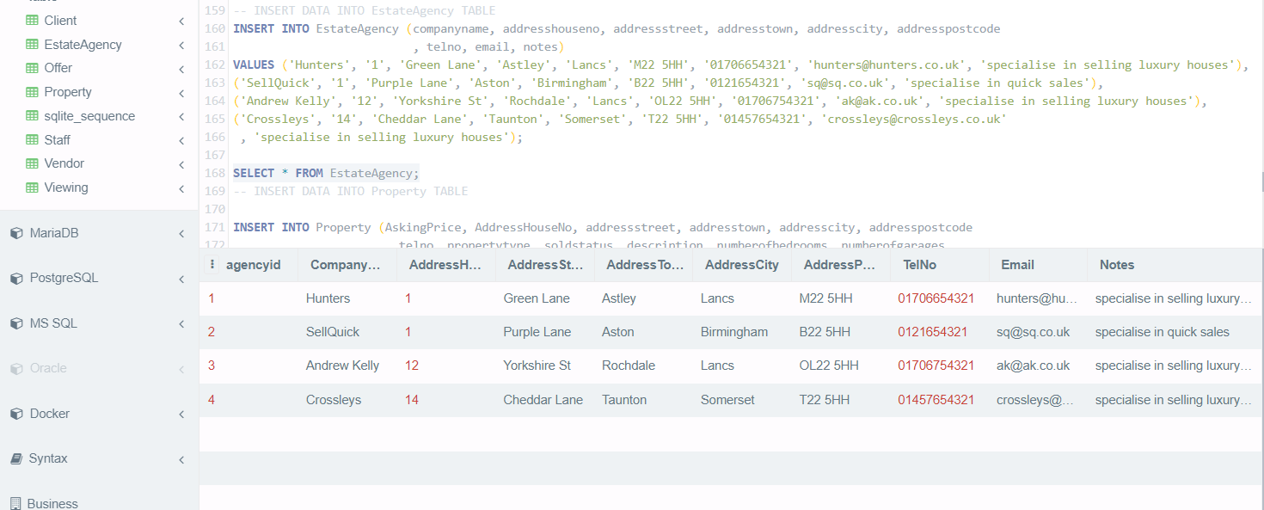

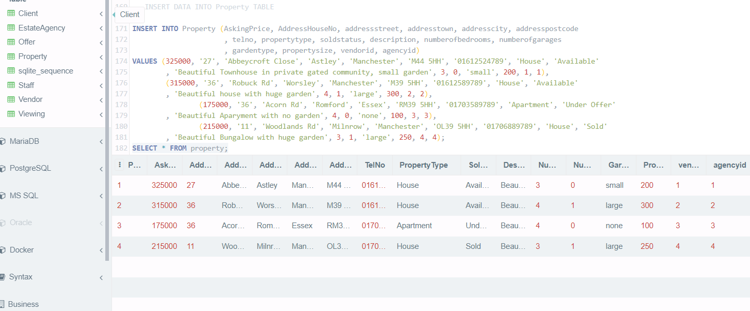

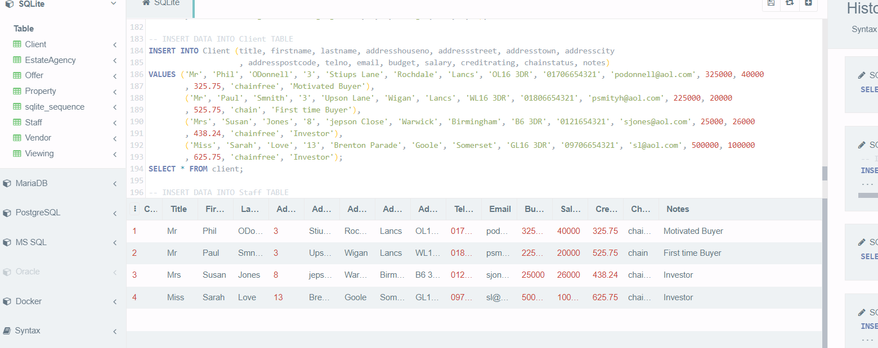

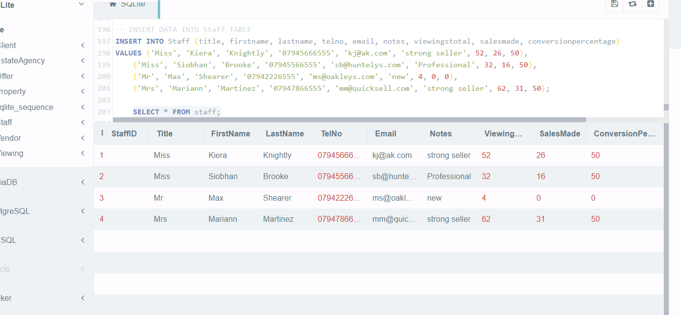

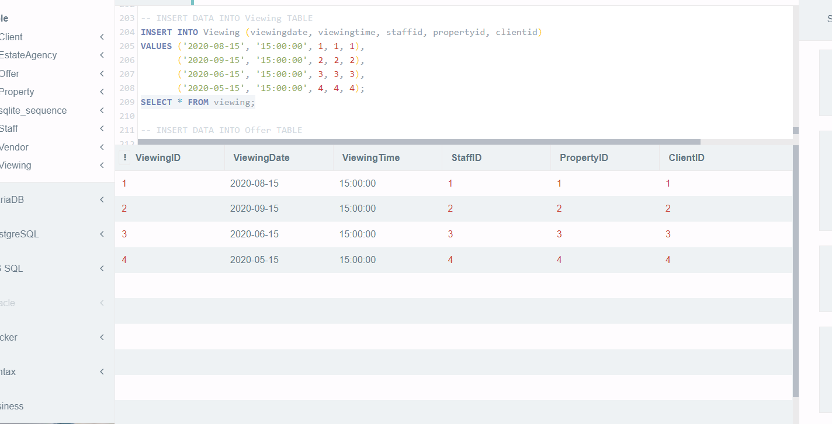

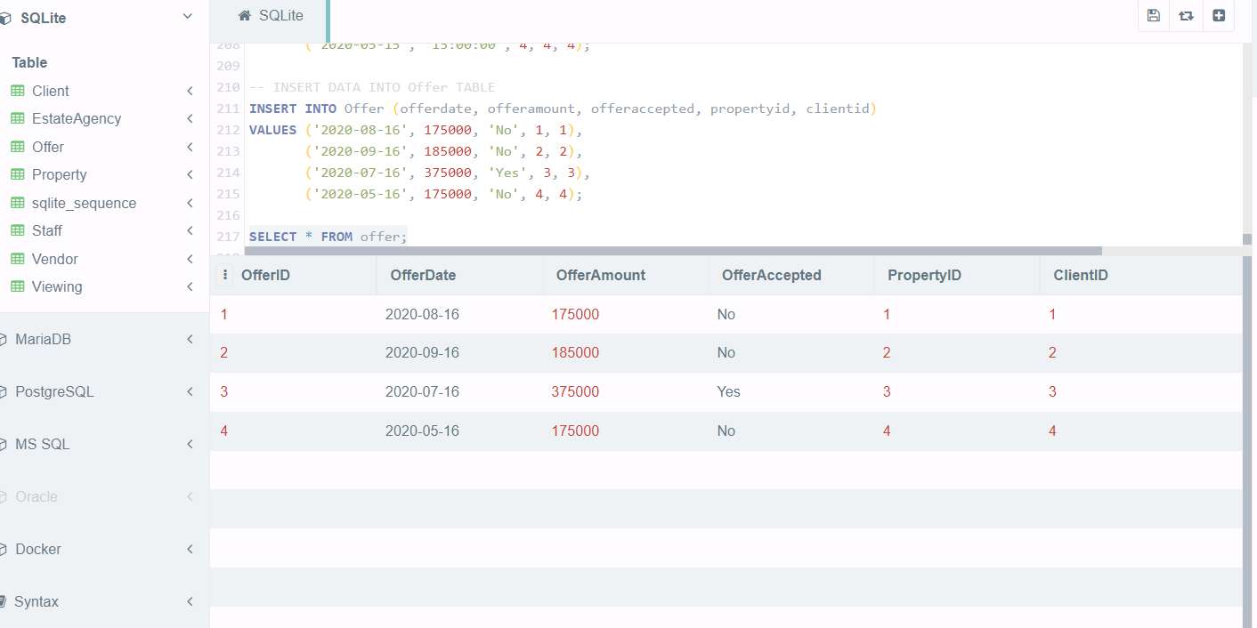

# Queries and Results

1. List all properties located in the city of Manchester with a list price of over £200,000

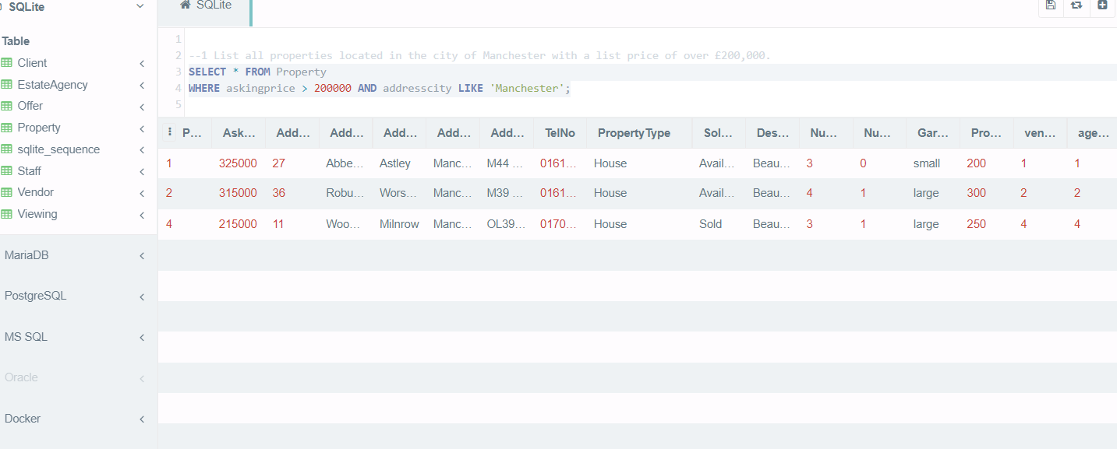

1. List all viewings that took place in August or September 2020 and the clients who requested the viewings

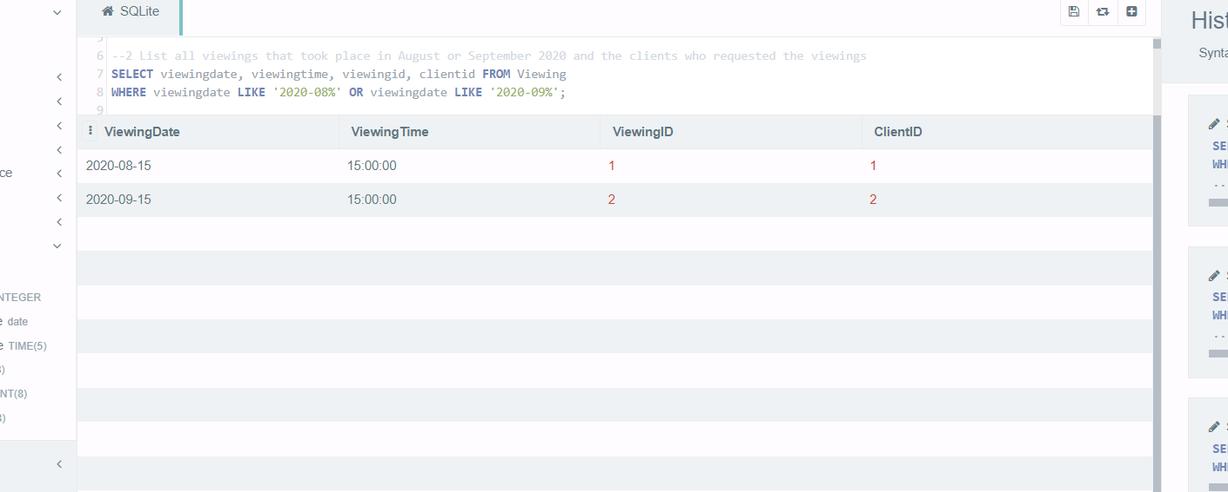

1. For each owner, list their total portfolio value (i.e. the total of all their properties’ prices) but only for properties which are houses

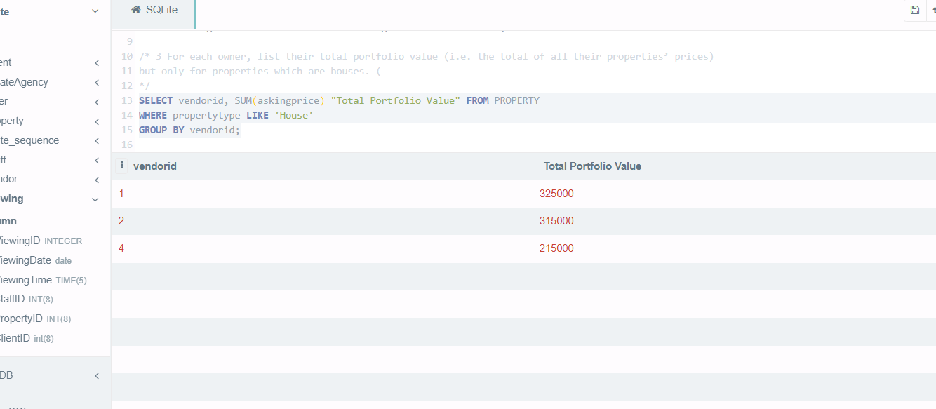

1. For each property, list the smallest offer made by clients and which client made the offer, but only for properties which have not been sold

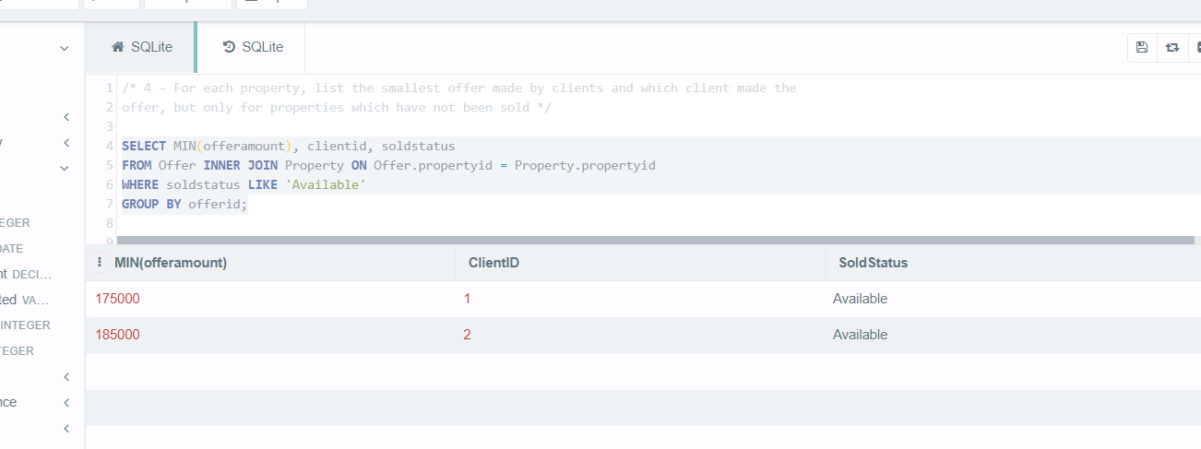

# Conclusion

* Some of my fields could have been shorter such as Postcode which should probably include a maximum size of 9 with a space, and similar for phone numbers.
* Maybe not all of my entities had to have a primary key that auto incremented eg EstateAgency could have been a 3 letter VAR abbreviation of their name.
* I set offer to client as a one to one relation in my ERD as technically an offer is unique and linked to a single client, but in hindsight a client can also place multiple offers on the same or multiple properties so one to many from that point of view.
* On question 4 I could have also joined against the client table to show the clients names rather than just their ID.
* In future I will pluralise entity names eg EstateAgencies, Clients etc..
* Seeing as I’m just starting I’ll google SQL best practises for future projects to prevent any bad habits.

# Appendix A

## SQL Code

*--1 List all properties located in the city of Manchester with a list price of over £200,000.*

*select * from Property*

*where askingprice > 200000 AND addresscity like 'Manchester';*

*--2 List all viewings that took place in August or September 2020 and the clients who requested the viewings*

*select viewingid, clientid from Viewing*

*where viewingdate LIKE '2020-08%' OR viewingdate LIKE '2020-09%';*

*/* 3 For each owner, list their total portfolio value (i.e. the total of all their properties’ prices)*

*but only for properties which are houses. (*

*\*/*

*select vendorid, SUM(askingprice) FROM PROPERTY*

*where propertytype like 'House'*

*group by vendorid;*

*/* 4 - For each property, list the smallest offer made by clients and which client made the*

*offer, but only for properties which have not been sold */*

*SELECT MIN(offeramount), clientid, soldstatus*

*FROM Offer INNER JOIN Property on Offer.propertyid = Property.propertyid*

*where soldstatus like 'Available'*

*group by offerid;*

*/\**

*Created by Phil ODonnell for Portfolio 1 Bootcamp 2021*

*\*/*

*PRAGMA foreign_keys = OFF;*

*DROP TABLE IF EXISTS Offer;*

*DROP TABLE IF EXISTS Viewing;*

*DROP TABLE IF EXISTS Staff;*

*DROP TABLE IF EXISTS Client;*

*DROP TABLE IF EXISTS Property;*

*DROP TABLE IF EXISTS EstateAgency;*

*DROP TABLE IF EXISTS Vendor;*

*PRAGMA foreign_keys = ON;*

*-- CREATE tables*

*create TABLE Vendor(*

*vendorid INTeger PRIMARY KEY AUTOINCREMENT*

*, Title VARCHAR(5)*

*, FirstName VARCHAR(100) not NULL*

*, LastName VARCHAR(100) not NULL*

*, AddressHouseNo VARCHAR(7) not NULL*

*, AddressStreet VARCHAR(255)*

*, AddressTown VARCHAR(255)*

*, AddressCity VARCHAR(255)*

*, AddressPostCode VARCHAR(10) not NULL*

*, TelNo VARCHAR(15) not NULL*

*, Email VARCHAR(100) not NULL*

*, Notes VARCHAR(255)*

*);*

*CREATE TABLE EstateAgency(*

*agencyid INTEGER PRIMARY KEY AUTOINCREMENT*

*, CompanyName VARCHAR(10) not NULL*

*, AddressHouseNo VARCHAR(7) not NULL*

*, AddressStreet VARCHAR(255)*

*, AddressTown VARCHAR(255)*

*, AddressCity VARCHAR(255)*

*, AddressPostCode VARCHAR(10) not NULL*

*, TelNo VARCHAR(15) not NULL*

*, Email VARCHAR(100) not NULL*

*, Notes VARCHAR(255)*

*);*

*CREATE TABLE Property(*

*PropertyID INTEGER PRIMARY KEY AUTOINCREMENT*

*, AskingPrice DECIMAL(7, 2) not NULL*

*, AddressHouseNo VARCHAR(7) not NULL*

*, AddressStreet VARCHAR(255)*

*, AddressTown VARCHAR(255)*

*, AddressCity VARCHAR(255)*

*, AddressPostCode VARCHAR(10) not NULL*

*, TelNo VARCHAR(15)*

*, PropertyType VARCHAR(20)*

*, SoldStatus VARCHAR(20)*

*, Description VARCHAR(255)*

*, NumberOfBedrooms INT(3) not NULL*

*, NumberOfGarages INT(2)*

*, GardenType VARCHAR(20)*

*, PropertySize INT(10)*

*, vendorid INTEGER*

*, agencyid INTEGER*

*, FOREIGN KEY(vendorid) REFERENCES Vendor(vendorid)*

*, FOREIGN key(agencyid) REFERENCES EstateAgency(agencyid)*

*);*

*create table Client(*

*ClientID intEGER primary KEY AUTOINCREMENT*

*, Title VARCHAR(5)*

*, FirstName VARCHAR(100) not NULL*

*, LastName VARCHAR(100) not NULL*

*, AddressHouseNo VARCHAR(7) not NULL*

*, AddressStreet VARCHAR(255)*

*, AddressTown VARCHAR(255)*

*, AddressCity VARCHAR(255)*

*, AddressPostCode VARCHAR(10) not NULL*

*, TelNo VARCHAR(15) not NULL*

*, Email VARCHAR(100) not NULL*

*, Budget DECIMAL(7, 2)*

*, Salary DECIMAL (7, 2)*

*, CreditRating DECIMAL(4, 2)*

*, ChainStatus VARCHAR(255)*

*, Notes VARCHAR(255)*

*);*

*CREATE TABLE Staff(*

*StaffID INTEGER PRIMARY KEY AUTOINCREMENT*

*, Title VARCHAR(5)*

*, FirstName VARCHAR(100) not NULL*

*, LastName VARCHAR(100) not NULL*

*, TelNo VARCHAR(15) not NULL*

*, Email VARCHAR(100) not NULL*

*, Notes VARCHAR(255)*

*, ViewingsTotal INT(5)*

*, SalesMade INT(5)*

*, ConversionPercentage DECIMAL(5, 2)*

*);*

*CREATE TABLE Viewing(*

*ViewingID INTEGER PRIMARY KEY AUTOINCREMENT*

*, ViewingDate date NOT NULL*

*, ViewingTime TIME(5)*

*, StaffID INT(8)*

*, PropertyID INTeger*

*, ClientID integer*

*, FOREIGN KEY(StaffID) REFERENCES Staff(StaffID)*

*, FOREIGN KEY(PropertyID) REFERENCES Property(PropertyID)*

*, FOREIGN KEY(ClientID) REFERENCES Client(ClientID)*

*);*

*CREATE TABLE Offer(*

*OfferID INTEGER PRIMARY KEY AUTOINCREMENT*

*, OfferDate DATE NOT NULL*

*, OfferAmount DECIMAL(7, 2) NOT NULL*

*, OfferAccepted VARCHAR(100) NOT NULL*

*, PropertyID INTEGER*

*, ClientID INTEGER*

*, FOREIGN KEY(PropertyID) REFERENCES Property(PropertyID)*

*, FOREIGN KEY(ClientID) REFERENCES Client(ClientID)*

*);*

*-- INSERT DATA INTO VENDOR TABLE*

*insert into Vendor (title, firstname, lastname, addresshouseno, addressstreet, addresstown, addresscity*

*, addresspostcode, telno, email, notes)*

*VALUES ('MR', 'Michael', 'Johnson', '26', 'Pitville Avenue', 'Birkenhead', 'Liverpool', 'L187JE', '07549175633',*

*'johnsonmichael291@gmail.com', 'Multi-Millionaire'),*

*('MR', 'David', 'Smith', '52', 'Smith St', 'Ealing', 'London', 'W6 1AG', '07546454646', 'p@sgdfgdfg.com', 'fjgghjjftjy'),*

*('MRS', 'Fiona', 'Lloyd', '52', 'Red St', 'Bury', 'Lancs', 'B6 1AG', '01456789555', 'F@sgdfgdfg.com', 'Nice lady'),*

*('MISS', 'Sarah', 'Butt', '25', 'Blue St', 'Hancoates', 'Lancs', 'BL6 1AG', '01203456789', 's@sgdfgdfg.com', 'Young Vendor');*

*-- INSERT DATA INTO EstateAgency TABLE*

*insert into EstateAgency (companyname, addresshouseno, addressstreet, addresstown, addresscity, addresspostcode*

*, telno, email, notes)*

*VALUES ('Hunters', '1', 'Green Lane', 'Astley', 'Lancs', 'M22 5HH', '01706654321', 'hunters@hunters.co.uk', 'specialise in selling luxury houses'),*

*('SellQuick', '1', 'Purple Lane', 'Aston', 'Birmingham', 'B22 5HH', '0121654321', 'sq@sq.co.uk', 'specialise in quick sales'),*

*('Andrew Kelly', '12', 'Yorkshire St', 'Rochdale', 'Lancs', 'OL22 5HH', '01706754321', 'ak@ak.co.uk', 'specialise in selling luxury houses'),*

*('Crossleys', '14', 'Cheddar Lane', 'Taunton', 'Somerset', 'T22 5HH', '01457654321', 'crossleys@crossleys.co.uk', 'specialise in selling luxury houses');*

*-- INSERT DATA INTO Property TABLE*

*INSERT INTO Property (AskingPrice, AddressHouseNo, addressstreet, addresstown, addresscity, addresspostcode*

*, telno, propertytype, soldstatus, description, numberofbedrooms, numberofgarages*

*, gardentype, propertysize, vendorid, agencyid)*

*VALUES (325000, '27', 'Abbeycroft Close', 'Astley', 'Manchester', 'M44 5HH', '01612524789', 'House', 'Available'*

*, 'Beautiful Townhouse in private gated community, small garden', 3, 0, 'small', 200, 1, 1),*

*(315000, '36', 'Robuck Rd', 'Worsley', 'Manchester', 'M39 5HH', '01612589789', 'House', 'Available'*

*, 'Beautiful house with huge garden', 4, 1, 'large', 300, 2, 2),*

*(175000, '36', 'Acorn Rd', 'Romford', 'Essex', 'RM39 5HH', '01703589789', 'Apartment', 'Under Offer'*

*, 'Beautiful Aparyment with no garden', 4, 0, 'none', 100, 3, 3),*

*(215000, '11', 'Woodlands Rd', 'Milnrow', 'Manchester', 'OL39 5HH', '01706889789', 'House', 'Sold'*

*, 'Beautiful Bungalow with huge garden', 3, 1, 'large', 250, 4, 4);*

*-- INSERT DATA INTO Client TABLE*

*INSERT INTO Client (title, firstname, lastname, addresshouseno, addressstreet, addresstown, addresscity*

*, addresspostcode, telno, email, budget, salary, creditrating, chainstatus, notes)*

*values ('Mr', 'Phil', 'ODonnell', '3', 'Stiups Lane', 'Rochdale', 'Lancs', 'OL16 3DR', '01706654321', 'podonnell@aol.com', 325000, 40000*

*, 325.75, 'chainfree', 'Motivated Buyer'),*

*('Mr', 'Paul', 'Smnith', '3', 'Upson Lane', 'Wigan', 'Lancs', 'WL16 3DR', '01806654321', 'psmityh@aol.com', 225000, 20000*

*, 525.75, 'chain', 'First time Buyer'),*

*('Mrs', 'Susan', 'Jones', '8', 'jepson Close', 'Warwick', 'Birmingham', 'B6 3DR', '0121654321', 'sjones@aol.com', 25000, 26000*

*, 438.24, 'chainfree', 'Investor'),*

*('Miss', 'Sarah', 'Love', '13', 'Brenton Parade', 'Goole', 'Somerset', 'GL16 3DR', '09706654321', 'sl@aol.com', 500000, 100000*

*, 625.75, 'chainfree', 'Investor');*

*-- INSERT DATA INTO Staff TABLE*

*INSERT INTO Staff (title, firstname, lastname, telno, email, notes, viewingstotal, salesmade, conversionpercentage)*

*VALUES ('Miss', 'Kiera', 'Knightly', '07945666555', 'kj@ak.com', 'strong seller', 52, 26, 50),*

*('Miss', 'Siobhan', 'Brooke', '07945566555', 'sb@huntelys.com', 'Professional', 32, 16, 50),*

*('Mr', 'Max', 'Shearer', '07942226555', 'ms@oakleys.com', 'new', 4, 0, 0),*

*('Mrs', 'Mariann', 'Martinez', '07947866555', 'mm@quicksell.com', 'strong seller', 62, 31, 50);*

*-- INSERT DATA INTO Viewing TABLE*

*INSERT INTO Viewing (viewingdate, viewingtime, staffid, propertyid, clientid)*

*VALUES ('2020-08-15', '15:00:00', 1, 1, 1),*

*('2020-09-15', '15:00:00', 2, 2, 2),*

*('2020-06-15', '15:00:00', 3, 3, 3),*

*('2020-05-15', '15:00:00', 4, 4, 4);*

*-- INSERT DATA INTO Offer TABLE*

*INSERT INTO Offer (offerdate, offeramount, offeraccepted, propertyid, clientid)*

*VALUES ('2020-08-16', 175000, 'No', 1, 1),*

*('2020-09-16', 185000, 'No', 2, 2),*

*('2020-07-16', 375000, 'Yes', 3, 3),*

*('2020-05-16', 175000, 'No', 4, 4);*